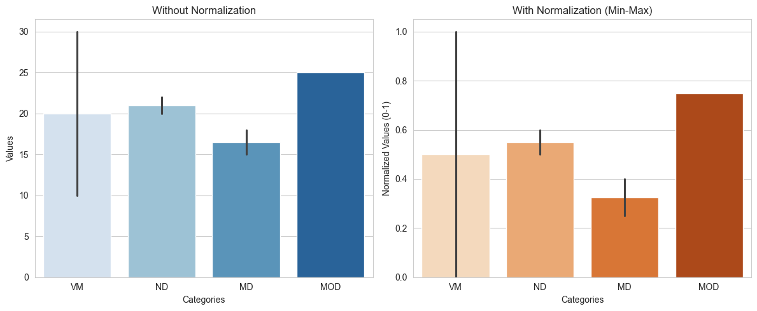

**Figure 4. Without and with Normalization Results**